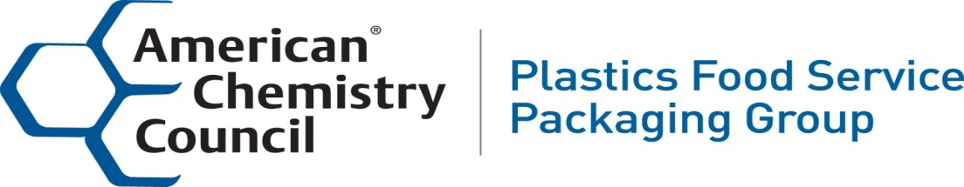
NYC Polystyrene (PS) Foam Foodservice Update – Nov 12, 2017

- In 2013, the NYC Council passed a legislation banning polystyrene (PS) foam foodservice products. NYC Department of Sanitation (DSNY) deemed polystyrene foam to be unrecyclable. The ban was set to take effect on July 1, 2015, giving businesses time to prepare for the moratorium. During the transition period, a coalition of restaurant owners, manufacturers, recyclers and foodservice industry leaders filed suit in the NY Supreme Court against the New York City de Blasio Administration to overturn the ban on foam foodservice.

- September 2015, the court ruled business provided sufficient evident to show polystyrene foam could be recycled, and lifted the ban.

- May 2017, the DSNY responded to the ruling by crafting an analysis claiming that PS recycling is not economical, contaminates the recycling stream and will result in a reduction a program’s recycling rate. The de Blasio administration is relying upon the analysis to reinstate the 2013 ban.

- September 2017, a coalition of restaurant owners, manufacturers, recyclers and foodservice industry leaders again filed suit in the NY Supreme Court, urging the city to forego its plans to ban foam in early November and instead establish a postconsumer recycling program. The suit would require the Department to comply with its statutorily mandated duty to recycle foam as previously ordered by the New York Supreme Court in September 2015.

- November 2017, DSNY has reinstituted a ban on foam foodservice packaging effective November 13, 2017. However, DSNY has confirmed the ban will not be enforced until May 14, 2018. Users of foam foodservice packaging are free to continue to use it in NYC at this time.

- Information about the Industry’s proposed recycling program, including educational videos, can be found at www.RAANYC.com.

- Here is a summary of the program:
- The recycling plan will cover virtually 100% of PS in NYC’s residential recycling stream whereas the proposed ban only covers a little more than 20% of NYC’s PS which means the roughly 80% of remaining PS will continued to be landfilled.
- Plastic Recycling, Inc., Indianapolis, Indiana is ready to purchase and pay to transport NYC’s PS by rail or barge out of NYC to its recycling facility starting today.
- A report by Skumatz Economic Research Associates shows the profitability of the recovery of PS relative to other materials currently accepted in DSNY’s recycling program. In fact, it shows that, even without the Dart investment, PS recovery is profitable and more profitable per ton than glass, aseptic, and ferrous materials.
- A report by Berkeley Research Group determined the PS recycling proposal results in an economic gain for NYC of more than $56 million per year.

